

**Polling District and Polling Place Review 2025**

**West Fenham Ward**

**Parliamentary Constituency:** Central and West

**(Proposed) Polling Districts:** Y01, Y02, Y03, Y04, Y05, Y06

The Local Government Boundary Commission for England are an independent body accountable to Parliament. They are responsible for reviewing councils to make sure their patterns of internal wards are fair and sensible. Their reviews include at least two rounds of public consultation before they make recommendations for change.

The final recommendations were published on 7 January 2025, and the new arrangements apply to local elections from 2026.

As a result of changes to ward boundaries the Acting Returning Officer (ARO) is conducting a review of polling districts and polling places to ensure that they are suitable for the new ward boundaries.

For more information on the local government boundary review visit: <https://www.lgbce.org.uk/all-reviews/newcastle-upon-tyne>

This document provides details of the review, along with the initial recommendations and comments of the Acting Returning Officer (ARO). Also, the election rules require the ARO to decide how many polling stations are required for each polling station and the ARO must allocate electors to the polling stations in such manner as they think most convenient.

These recommendations will be open to all residents, stakeholders, and any interested parties. We shall be seeking representations from local disability groups on the accessibility and suitability of polling places. Any comments should be addressed in the first instance to pollingplaces@newcastle.gov.uk where they will be collated on behalf of the (Acting) Returning Officer.

We considered the following factors:

* **Identifying new polling places:** We will look for new polling places in areas where the existing provision is unsuitable or unavailable.
* **Feedback:** We will consider feedback received following recent elections, consultation from members of the public, elected members, and other stakeholders.
* **Accessibility:** We will try to ensure that every polling place is accessible to electors with disabilities.
* **Facilities**: We will make sure that all electors have such reasonable facilities for voting as are practicable in the circumstances.
* **Elector numbers:** We will try to comply with the Electoral Commission guidance on the maximum number of electors that should be allocated to a polling station which should not exceed 2,250.
* **Future housing developments**: We will consider the impact of proposed housing developments on polling station electorates.

**(Current) West Fenham Ward**

This map shows the current ward and polling district boundaries and the polling places.

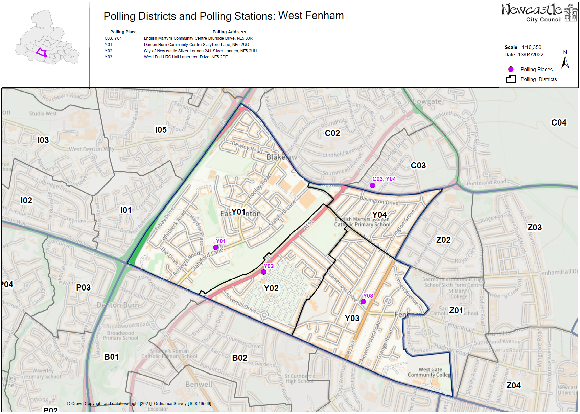

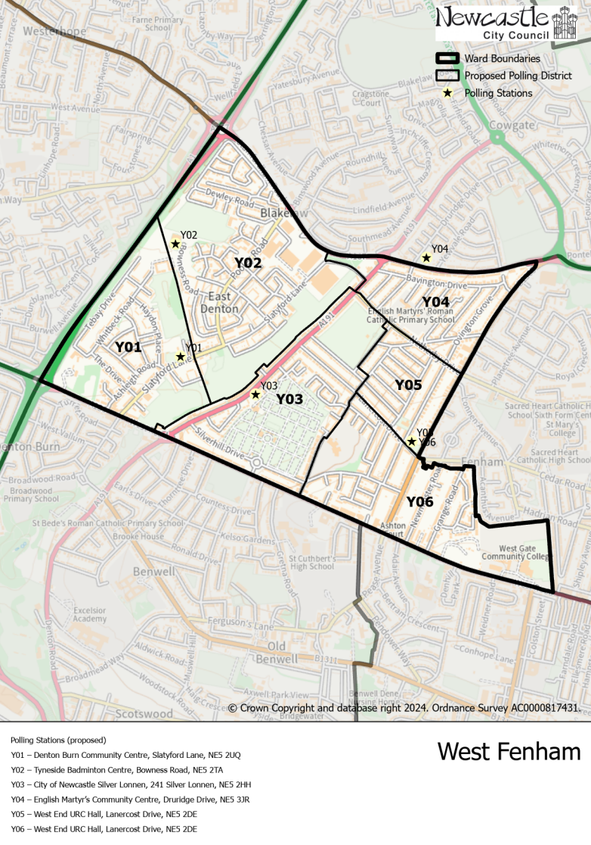**(New)**

**West Fenham Ward**

This map shows the new ward and the proposed polling districts and the proposed polling places.

* **Y01**

Denton Burn Community Centre, Slatyford Lane, NE5 2UQ

* **Y02**

Tyneside Badminton Centre, Bowness Road, NE5 2TA

* **Y03**

City of Newcastle Silver Lonnen, 241 Silver Lonnen, NE5 2HH

* **Y04**

English Martyr’s Community Centre, Druridge Drive, NE5 3JR

* **Y05**

West End URC Hall, Lanercost Drive, NE5 2DE

* **Y06**

West End URC Hall, Lanercost Drive, NE5 2DE

**West Fenham Ward**

**Polling District Y01**

|  |  |
| --- | --- |
| **Current Polling District** | **Current Polling Place** |
| Y01 (part of) | Denton Burn Community Centre, Slatyford Lane, NE5 2UQ |

|  |  |  |
| --- | --- | --- |
| **Proposed Polling District** | **Predicted**  **Polling Station Electorate** | **Proposed Polling Place** |
| Y01 | 594 | Denton Burn Community Centre, Slatyford Lane, NE5 2UQ |

|  |
| --- |
| **Considerations and Proposals** |
| Part of the current Y01 district would form the proposed Y01 district. Includes properties to the west of Caroline Pitt Cottages.  No change to the polling place. |

|  |
| --- |
| **Preliminary Consultation – Elected Members comments and feedback** |
| Councillor Mark Mitchell objects to any changes to the stations or districts. |

**West Fenham Ward**

**Polling District Y02**

|  |  |
| --- | --- |
| **Current Polling District** | **Current Polling Place** |
| Y01 (part of) | Denton Burn Community Centre, Slatyford Lane, NE5 2UQ |

|  |  |  |
| --- | --- | --- |
| **Proposed Polling District** | **Predicted**  **Polling Station Electorate** | **Proposed Polling Place** |
| Y02 | 1006 | Tyneside Badminton Centre, Bowness Road, NE5 2TA |

|  |
| --- |
| **Considerations and Proposals** |
| Part of the current Y01 district would form the proposed Y02 district. Includes properties to the east of Caroline Pitt Cottages.  Tyneside Badminton Centre is the suggested polling station for this district. Site visit was carried out on the 24 July 2025 and the building was deemed suitable for use. |

|  |
| --- |
| **Preliminary Consultation – Elected Members comments and feedback** |
| Councillor Mark Mitchell objects to any changes to the stations or districts. |

**West Fenham Ward**

**Polling District Y03**

|  |  |
| --- | --- |
| **Current Polling District** | **Current Polling Place** |
| Y02 (full) | City of Newcastle Silver Lonnen, 241 Silver Lonnen, NE5 2HH |

|  |  |  |
| --- | --- | --- |
| **Proposed Polling District** | **Predicted**  **Polling Station Electorate** | **Proposed Polling Place** |
| Y03 | 758 | City of Newcastle Silver Lonnen, 241 Silver Lonnen, NE5 2HH |

|  |
| --- |
| **Considerations and Proposals** |
| Current Y02 would become the proposed Y03. No change to the polling district boundary.  No change to the polling station. |

|  |
| --- |
| **Preliminary Consultation – Elected Members comments and feedback** |
| Councillor Mark Mitchell objects to any changes to the stations or districts. |

**West Fenham Ward**

**Polling District Y04**

|  |  |
| --- | --- |
| **Current Polling District** | **Current Polling Place** |
| Y04 (full) | English Martyr’s Community Centre, Druridge Drive, NE5 3JR |

|  |  |  |
| --- | --- | --- |
| **Proposed Polling District** | **Predicted**  **Polling Station Electorate** | **Proposed Polling Place** |
| Y04 | 789 | English Martyr’s Community Centre, Druridge Drive, NE5 3JR |

|  |
| --- |
| **Considerations and Proposals** |
| No changes to the polling district boundary.  No change to the polling place. English Martyr's Community Centre is suggested as a double polling station for the proposed C03 and Y04 districts. |

|  |
| --- |
| **Preliminary Consultation – Elected Members comments and feedback** |
| Councillor Mark Mitchell objects to any changes to the stations or districts. |

**West Fenham Ward**

**Polling District Y05**

|  |  |
| --- | --- |
| **Current Polling District** | **Current Polling Place** |
| Y03 (part of) | West End URC Hall, Lanercost Drive, NE5 2DE |

|  |  |  |
| --- | --- | --- |
| **Proposed Polling District** | **Predicted**  **Polling Station Electorate** | **Proposed Polling Place** |
| Y05 | 512 | West End URC Hall, Lanercost Drive, NE5 2DE |

|  |
| --- |
| **Considerations and Proposals** |
| Part of the current Y03 district would form the proposed Y05 district. New district includes properties to the North of Lanercost Drive and to the west of Two Ball Lonnen.  Current Y03 loses part of the district to Wingrove ward.  No change to the polling place.  West End URC Hall is suggested as a double polling station for the proposed districts Y05 and Y06. |

|  |
| --- |
| **Preliminary Consultation – Elected Members comments and feedback** |
| Councillor Mark Mitchell objects to any changes to the stations or districts. |

**West Fenham Ward**

**Polling District Y06**

|  |  |
| --- | --- |
| **Current Polling District** | **Current Polling Place** |
| Y03 (part of) | West End URC Hall, Lanercost Drive, NE5 2DE |

|  |  |  |
| --- | --- | --- |
| **Proposed Polling District** | **Predicted**  **Polling Station Electorate** | **Proposed Polling Place** |
| Y06 | 770 | West End URC Hall, Lanercost Drive, NE5 2DE |

|  |
| --- |
| **Considerations and Proposals** |
| Part of the current Y03 district would form the proposed Y06 district. Loses properties to the North of Lanercost Drive.  No change to the polling place. West End URC Hall is suggested as a double polling station for the proposed districts Y05 and Y06.  Stocksfield Avenue Primary was considered, but it was deemed that this building would not be a viable option to use as a polling station. |

|  |
| --- |
| **Preliminary Consultation – Elected Members comments and feedback** |
| Councillor Mark Mitchell objects to any changes to the stations or districts. |